March 27, 2015
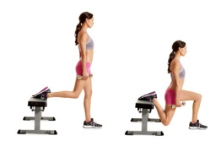
Lower Body
Quadriceps Exercises | # of Reps | Weight/Level | Notes for Next Time
Bulgarian Split Squat | 12
Bulgarian Split Squat | 10
Bulgarian Split Squat | 8 |  | 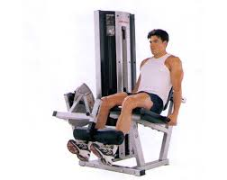
Bulgarian Split Squat | 6
Bulgarian Split Squat | 12
Leg Extensions | 12
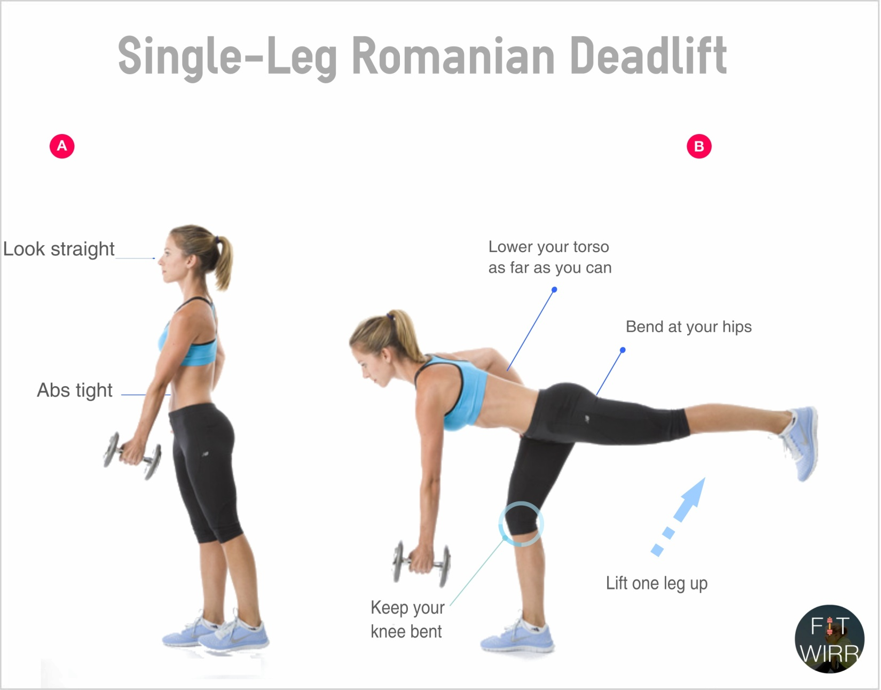
Hamstrings Exercises | # of Reps | Weight/Level | Notes for Next Time
Single Leg Deadlift | 12
Single Leg Deadlift | 10
Single Leg Deadlift | 8
Single Leg Deadlift | 6
Single Leg Deadlift | 12 |  | 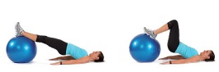
Ball Leg Curl | 12

Calf Exercises | # of Reps | Weight/Level | 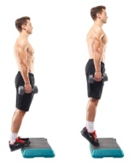  Notes for Next Time
Stand Dumbbell Raises | 12
Stand Dumbbell Raises | 10
Stand Dumbbell Raises | 8
Stand Dumbbell Raises | 6
Stand Dumbbell Raises | 12 |  | 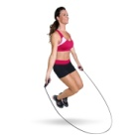
Jump Rope | 12 30 |  | Do this anywhere from 30 to 60 seconds

Abdominal Exercises | # of Reps | Weight/Level | Notes for Next Time
Ball Crunches | 12 10 |  | 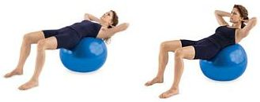  Hold a weight on chest to up the intensity
Ball Crunches | 10 15
Ball Crunches | 8 20
Ball Crunches | 6 25
Ball Crunches | 12 20 |  | 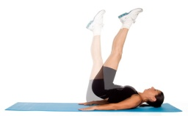
Butt Ups (Hip lifts) | 12 (As many as you can!)

