March 25, 2015
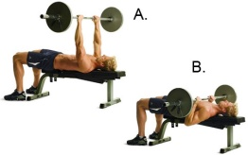
Upper Body
Chest Exercises | # of Reps | Weight/Level | Notes for Next Time
Barbell Bench Press | 12
Barbell Bench Press | 10
Barbell Bench Press | 8
Barbell Bench Press | 6
Barbell Bench Press | 12
Push-ups | 12
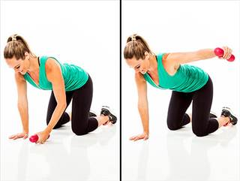
Shoulders Exercises | # of Reps | Weight/Level | Notes for Next Time
Kneeling Side Raise | 12
Kneeling Side Raise | 10
Kneeling Side Raise | 8 |  | 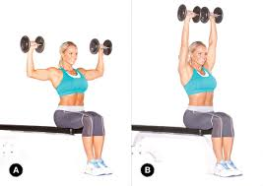
Kneeling Side Raise | 6
Kneeling Side Raise | 12
Seated Press | 12
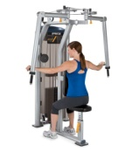
Back Exercises | # of Reps | Weight/Level | Notes for Next Time
Rear Delt Fly | 12 |  | Use the leg extension machine. Sit with your
Rear Delt Fly | 10 |  | chest against the back of the chair.
Rear Delt Fly | 8 |  | 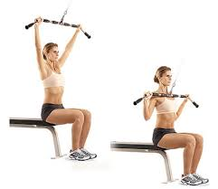
Rear Delt Fly | 6
Rear Delt Fly | 12
Wide-Grip Pulldowns | 12

Triceps Exercises | # of Reps | Weight/Level | 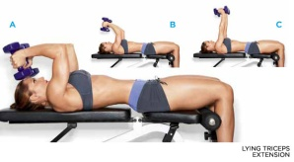  Notes for Next Time
Lying Dumbbell Ext. | 12
Lying Dumbbell Ext. | 10
Lying Dumbbell Ext. | 8 |  | 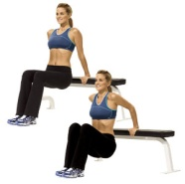
Lying Dumbbell Ext. | 6
Lying Dumbbell Ext. | 12
Bench Dips | 12

Biceps Exercises | # of Reps | Weight/Level | 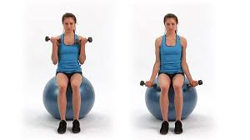  Notes for Next Time
Seated Dumbbell Curls | 12 |  | Sit on the ball to work your core
Seated Dumbbell Curls | 10
Seated Dumbbell Curls | 8
Seated Dumbbell Curls | 6 |  | 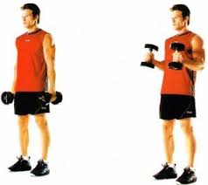
Seated Dumbbell Curls | 12
Hammer Curls | 12

