March 19, 2015
Upper Body
Chest Exercises | # of Reps | Weight/Level | 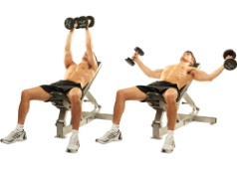  Notes for Next Time
Dumbbell Flies | 12
Dumbbell Flies | 10
Dumbbell Flies | 8
Dumbbell Flies | 6
Dumbbell Flies | 12
Push-ups | 12
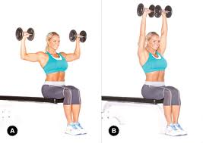
Shoulders Exercises | # of Reps | Weight/Level | Notes for Next Time
Seated Dumbbell Press | 12
Seated Dumbbell Press | 10
Seated Dumbbell Press | 8 |  | 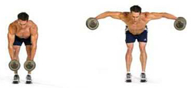
Seated Dumbbell Press | 6
Seated Dumbbell Press | 12
Bent-Over Raises | 12
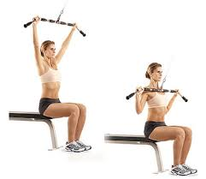
Back Exercises | # of Reps | Weight/Level | Notes for Next Time
Wide-Grip Pulldowns | 12
Wide-Grip Pulldowns | 10
Wide-Grip Pulldowns | 8
Wide-Grip Pulldowns | 6 |  | 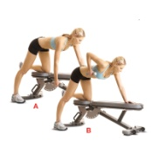
Wide-Grip Pulldowns | 12
Lawn Mower Rows | 12

Triceps Exercises | # of Reps | Weight/Level | 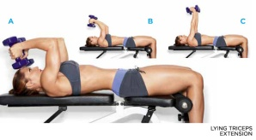  Notes for Next Time
Lying Dumbbell Ext. | 12
Lying Dumbbell Ext. | 10
Lying Dumbbell Ext. | 8 |  | 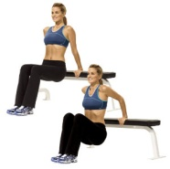
Lying Dumbbell Ext. | 6
Lying Dumbbell Ext. | 12
Bench Dips | 12

Biceps Exercises | # of Reps | Weight/Level | 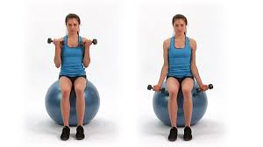  Notes for Next Time
Seated Dumbbell Curls | 12 |  | Sit on the ball to work your core
Seated Dumbbell Curls | 10
Seated Dumbbell Curls | 8
Seated Dumbbell Curls | 6 |  | 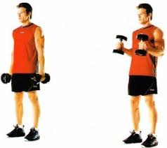
Seated Dumbbell Curls | 12
Hammer Curls | 12

