March 17, 2015
Lower Body
Quadriceps Exercises | # of Reps | Weight/Level | 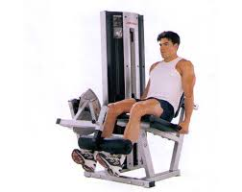  Notes for Next Time
Leg Extensions | 12
Leg Extensions | 10
Leg Extensions | 8
Leg Extensions | 6
Leg Extensions | 12 |  | 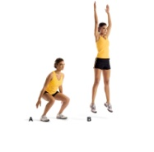
Jump Ups (see notes) | 12 |  | Swat down and touch floor between knees; jump up with arms over head – as high as you can; repeat 12 times
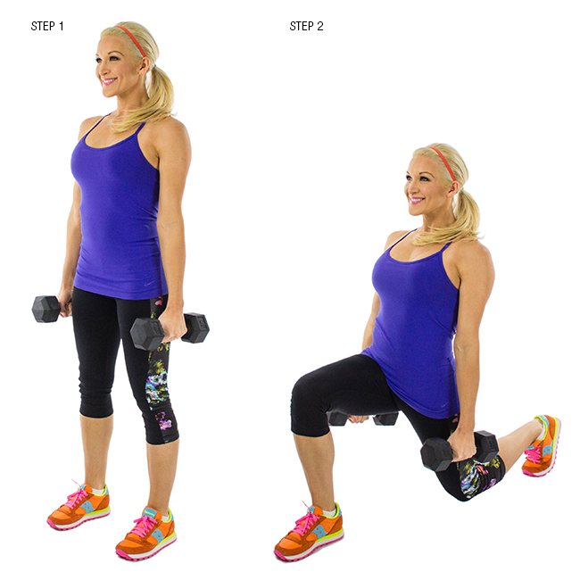
Hamstrings Exercises | # of Reps | Weight/Level | Notes for Next Time
Dumbbell Lunges | 12
Dumbbell Lunges | 10
Dumbbell Lunges | 8
Dumbbell Lunges | 6
Dumbbell Lunges | 12 |  | 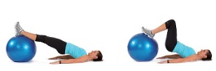
Ball Leg Curl | 12
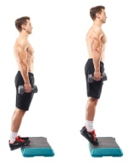
Calf Exercises | # of Reps | Weight/Level | Notes for Next Time
Stand Dumbbell Raises | 12
Stand Dumbbell Raises | 10
Stand Dumbbell Raises | 8
Stand Dumbbell Raises | 6 |  | 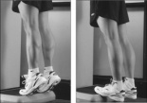
Stand Dumbbell Raises | 12
Standing Raises | 12 30

Abdominal Exercises | # of Reps | Weight/Level | 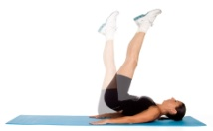  Notes for Next Time
Butt Lifts (Butt Ups) | 12 10
Butt Lifts (Butt Ups) | 10 15
Butt Lifts (Butt Ups) | 8 20
Butt Lifts (Butt Ups) | 6 25
Butt Lifts (Butt Ups) | 12 20
Mat Crunches | 12 (As many as you can!)

