March 2, 2015
Upper Body
Chest Exercises | # of Reps | Weight/Level | 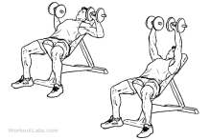  Notes for Next Time
Incline Dumbbell Press | 12
Incline Dumbbell Press | 10
Incline Dumbbell Press | 8
Incline Dumbbell Press | 6
Incline Dumbbell Press | 12
Push-ups | 12
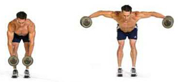
Shoulders Exercises | # of Reps | Weight/Level | Notes for Next Time
Bent-over Raises | 12 |  | 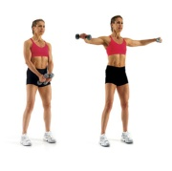
Bent-over Raises | 10
Bent-over Raises | 8
Bent-over Raises | 6
Bent-over Raises | 12
Side Raises | 12
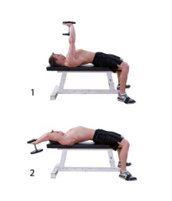
Back Exercises | # of Reps | Weight/Level | Notes for Next Time
Dumbbell Pullovers | 12
Dumbbell Pullovers | 10
Dumbbell Pullovers | 8
Dumbbell Pullovers | 6 |  | 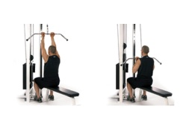
Dumbbell Pullovers | 12
Reverse grip Pulldowns | 12

Triceps Exercises | # of Reps | Weight/Level | 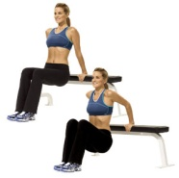  Notes for Next Time
Bench Dips | 12 5 | 0
Bench Dips | 10 7 | 0
Bench Dips | 8 9 | 0
Bench Dips | 6 12 | 0
Bench Dips | 12 12 | 0 | 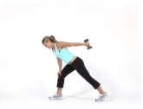
Mule Kicks | 12

Biceps Exercises | # of Reps | Weight/Level | 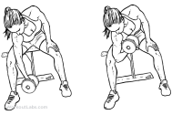  Notes for Next Time
Concentrated Curls | 12
Concentrated Curls | 10
Concentrated Curls | 8 |  | 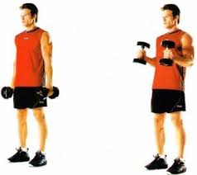
Concentrated Curls | 6
Concentrated Curls | 12
Hammer Curls | 12

