Day 20 February 3, 2015
Upper Body
Chest Exercises | # of Reps | Weight/Level | 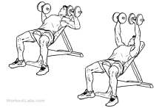  Notes for Next Time
Incline Dumbbell Press | 12
Incline Dumbbell Press | 10
Incline Dumbbell Press | 8
Incline Dumbbell Press | 6
Incline Dumbbell Press | 12
Push-ups | 12
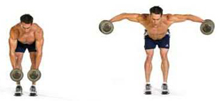
Shoulders Exercises | # of Reps | Weight/Level | Notes for Next Time
Bent-over Raises | 12 |  | 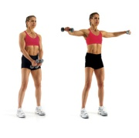
Bent-over Raises | 10
Bent-over Raises | 8
Bent-over Raises | 6
Bent-over Raises | 12
Side Raises | 12
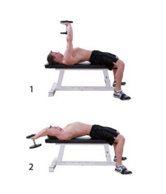
Back Exercises | # of Reps | Weight/Level | Notes for Next Time
Dumbbell Pullovers | 12
Dumbbell Pullovers | 10
Dumbbell Pullovers | 8
Dumbbell Pullovers | 6 |  | 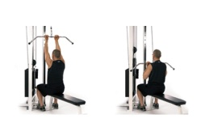
Dumbbell Pullovers | 12
Reverse grip Pulldowns | 12

Triceps Exercises | # of Reps | Weight/Level | 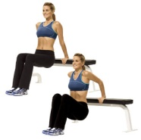  Notes for Next Time
Bench Dips | 12 5
Bench Dips | 10 7
Bench Dips | 8 9
Bench Dips | 6 12
Bench Dips | 12 12
Mule Kicks | 12

Biceps Exercises | # of Reps | Weight/Level | Notes for Next Time
Seated Dumbbell Curls | 12
Seated Dumbbell Curls | 10
Seated Dumbbell Curls | 8
Seated Dumbbell Curls | 6
Seated Dumbbell Curls | 12
Hammer Curls | 12

