Day 18 January 30, 2015
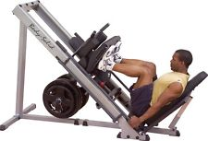
Lower Body
Quadriceps Exercises | # of Reps | Weight/Level | Notes for Next Time
Leg Press Machine | 12
Leg Press Machine | 10 |  | 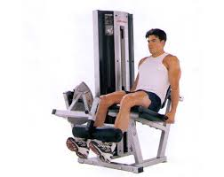
Leg Press Machine | 8
Leg Press Machine | 6
Leg Press Machine | 12
Seated Leg Extension | 12
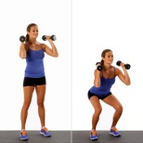
Hamstrings Exercises | # of Reps | Weight/Level | Notes for Next Time
Dumbbell Squats | 12
Dumbbell Squats | 10
Dumbbell Squats | 8
Dumbbell Squats | 6
Dumbbell Squats | 12 |  | 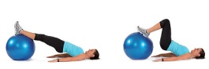
Ball Leg Curl | 12 |  | Use the 2 6-lb. balls under each foot

Calf Exercises | # of Reps | Weight/Level | 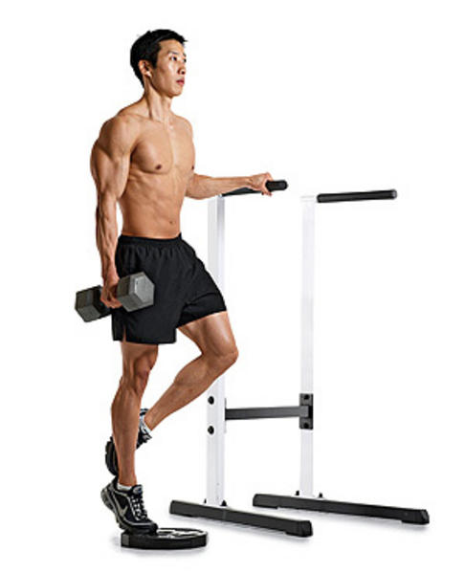  Notes for Next Time
Standing Heel Raises | 12
Standing Heel Raises | 10
Standing Heel Raises | 8
Standing Heel Raises | 6 |  | 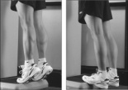
Standing Heel Raises | 12
Standing Raises | 12 30
Abdominal Exercises | # of Reps | Weight/Level | Notes for Next Time
Mat crunches | 12 10
Mat crunches | 10 15
Mat crunches | 8 20 |  | 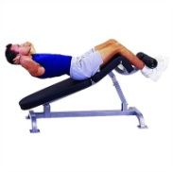
Mat crunches | 6 25
Mat crunches | 12 20
Decline Bench | 12

